**Aim:** To understand and work with Input and Output of data

**IDE:** R Studio

**Programs:**

Write and execute R script to understand Input and output of data

1. Print "R Programming"

2. Print Your Name On screen.

3. Print Address on screen.

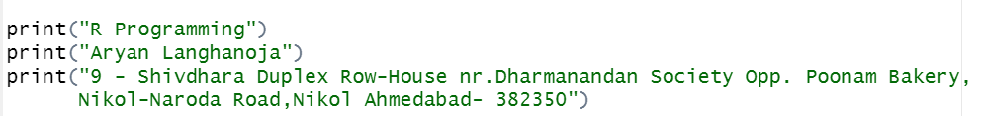

**Output:**

NOTE: Attach the screenshots of the output

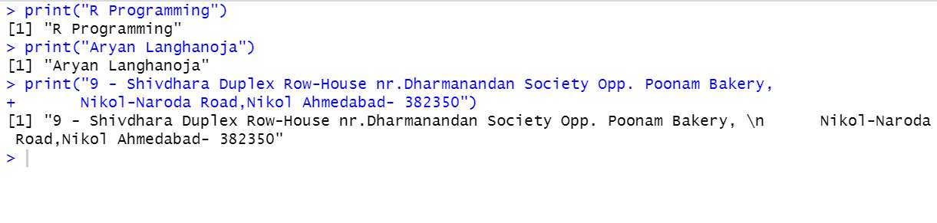**Observation and Learnings:**

________________________________________________________________________________________________________________________________________________________________________________________________________________________________________________________________________________________________________________________________________________________________________________________________________________________________________________________________________________________________________________________________________________________________________________________________________________________________________